|  |  |
| --- | --- |
| **Test Case:** *Pesquisa inteligencia artificial*  **Expected Result:** *Result OK*  **Status:** | **Date :** *24/08/2020*  **Hour:** *14:25* |

**1. OBJECTIVE**

This document aims to provide proof of the tests run for application validation.

2. EVIDENCE OF TEST STEPS

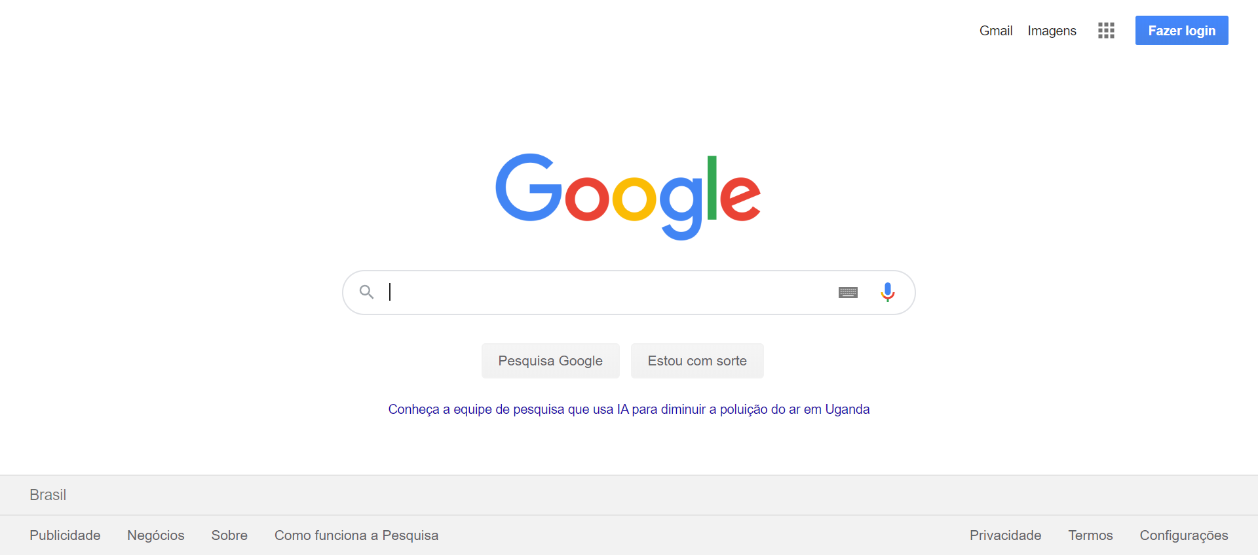

|  |  |
| --- | --- |
| Action: Navigate | Action time: 00:00:23 |
| Resultado expect: The page was successfully loaded | Resultado obtained: The page was successfully loaded |

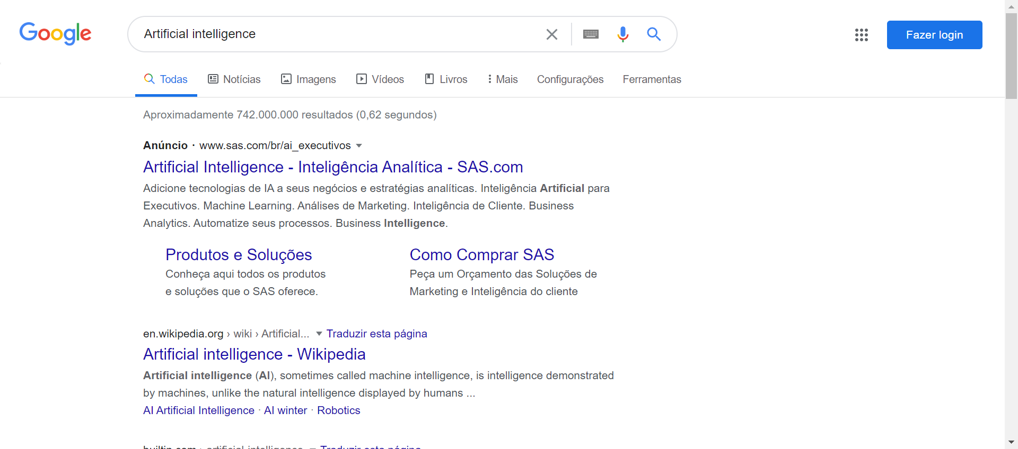

|  |  |
| --- | --- |
| Action: SendKeys | Action time: 00:00:02 |
| Resultado expect: The field was successfully filled | Resultado obtained: The field was successfully filled |

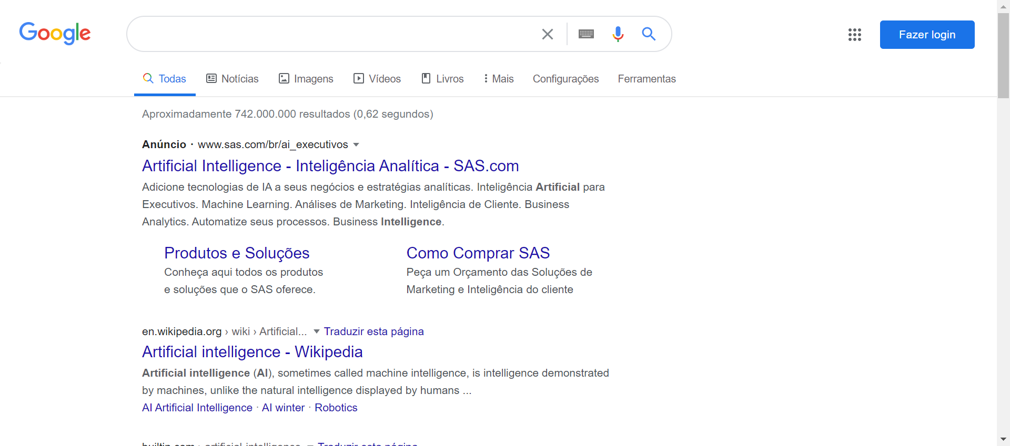

|  |  |
| --- | --- |
| Action: Do the action | Action time: 00:00:00 |
| Resultado expect: The action is successfully made | Resultado obtained: The action is successfully made |

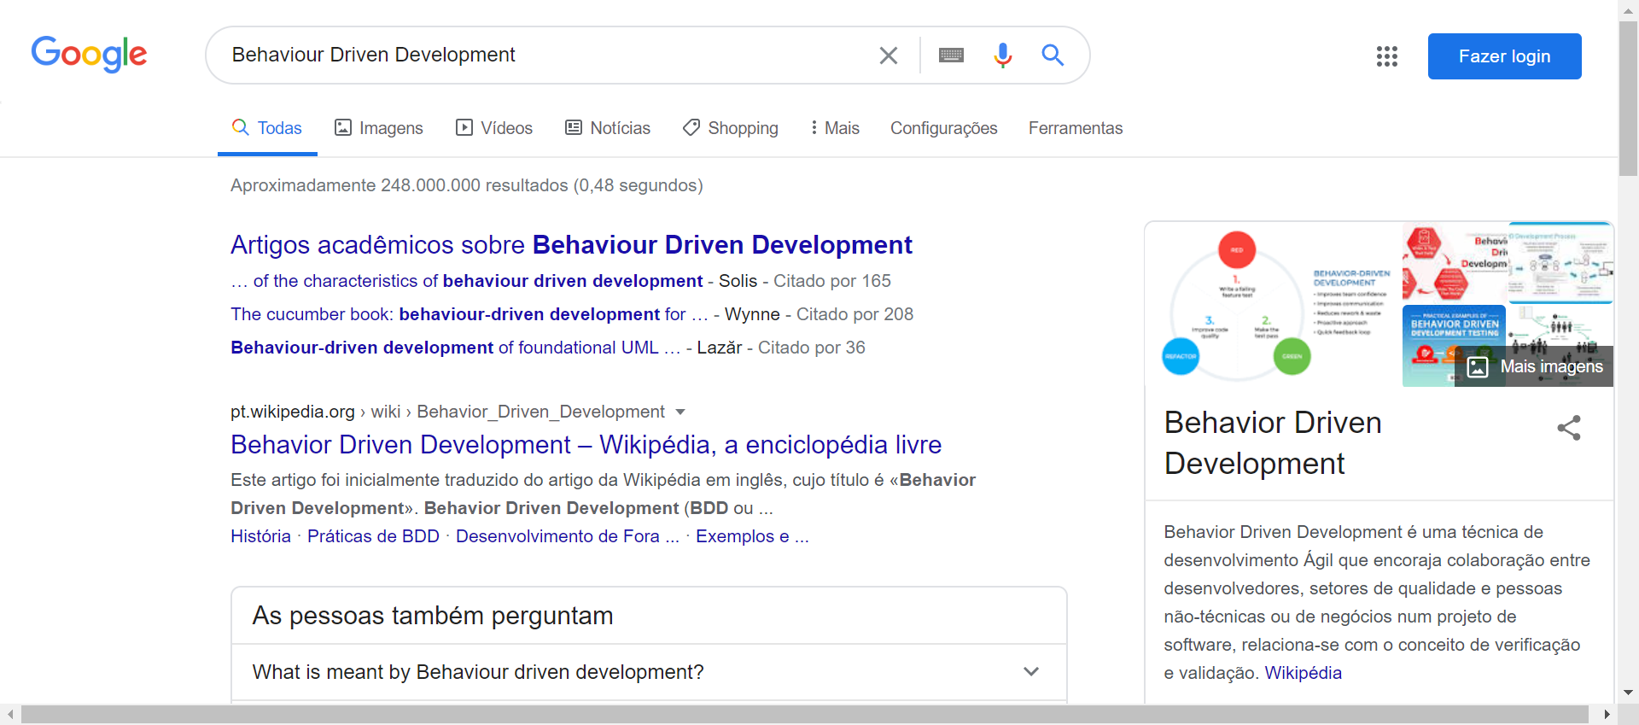

|  |  |
| --- | --- |
| Action: SendKeys | Action time: 00:00:01 |
| Resultado expect: The field was successfully filled | Resultado obtained: The field was successfully filled |



|  |  |
| --- | --- |
| Action: getText | Action time: 00:00:00 |
| Resultado expect: The text is successfully retrieved | Resultado obtained: The text is successfully retrieved |